DEPARTMENT OF PUBLIC HEALTH SCIENCES 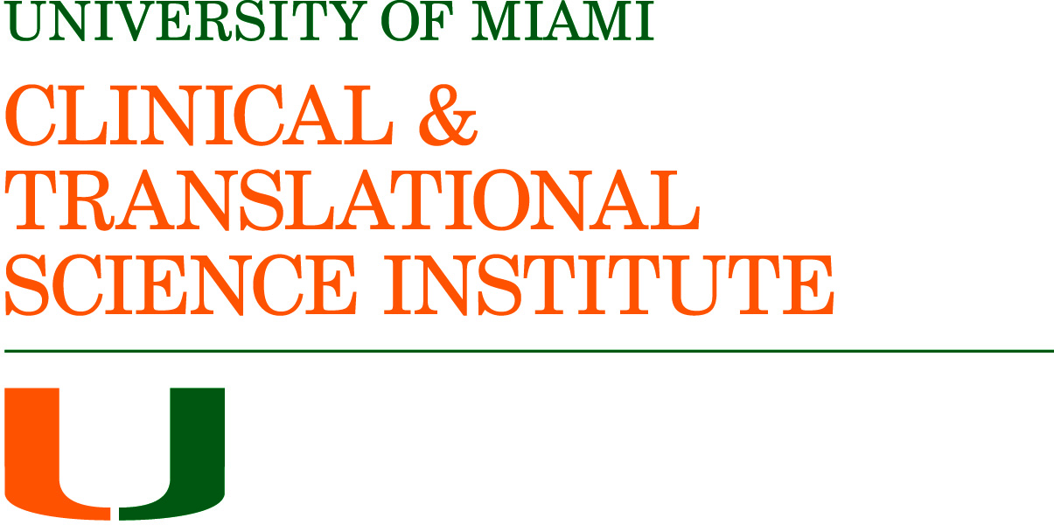
DIVISION OF BIOSTATISTICS
Biostatistics Collaboration and Consulting Core (BCCC)
Support Request Form

Please complete the information below and e-mail to Maria Jimenez-Rodriguez at mjrodriguez@biostat.med.miami.edu. The BCCC will contact you as soon as possible to address your needs.

All fields are required Date _______________________
Principal Investigator First and Last Name:
Principal Investigator Id # (C #):
Principal Investigator e-mail:
Principal Investigator Department, Division, or Institute:

Position: Faculty Fellow Resident Student/Post Doc. Other
If faculty, please specify position: Assistant Professor Associate Professor Full Professor
eraCommons username: ______________ (required for all investigators using services funded by CTSI for federal reporting)

Is this mentored research? ____ Yes ____ No
If Yes, name of Mentor is ___________________________ E-mail of Mentor ___________________________

Seeking support under Miami CTSI: Yes No
If Yes, indicate priority area(s) appropriate to your research
K-Award
CTSI/Institutionally funded pilot study
NIH Grant submission
If Yes, Check all that apply to your research:
Health disparities Medically underserved communities
Minority health
Obesity Substance abuse Sexually transmitted diseases Low-birth weight babies
Creation of new fields of study at the intersection between existing fields
Translational, and interdisciplinary, e.g. co-investigators from at least two schools/discipline
Collaborative, e.g. co-investigators from different scientific/clinical fields/subspecialties
Using more than one CTSI Component’s services/resources or resources from another NIH-funded
Program grant

Stage of Research:
Design (no data collected) Data Collection Analysis (data collected)
Peer Review Grant Preparation

Check all that apply: Funding source for project: (check all that apply):
Data analysis National Institute of Health
Power analysis National Cancer Institute
Study design American Cancer Society
Hypothesis generation National Science Foundation
New grant application Pharmaceutical Company
Revised grant application Private foundation
Manuscript preparation / review Institutional
Presentation / poster / abstract Not funded
REDCap Support REDCap
Other Other
Is this project approved by the University of Miami IRB? Yes No
If Yes, IRB Number:
Reason for non-approval:

Are you under any deadline(s): Yes No
If so, what is/are the deadline(s):
Project(s) Title(s):

Please provide a brief description of your request:

Please provide a brief description of the data that you have collected if any:

The BCCC is a cost center, and fee for work not supported under the Miami CTSI will be the responsibility of the investigator, and will be determined based on scope of project and estimated workload.

I (we) agree that reference to / and acknowledgement of the collaboration in publications or reports will be made in consultation with the BCCC, and that the BCCC will receive a copy of the publication. Authorship policy accepted by UMMSM and described in BCCC manual applies. Additionally, work supported under the Miami CTSI will include the following acknowledgment:

This work was conducted with support from the Miami Clinical and Translational Sciences Institute (National Center for Advancing Translational Science (GRANT # 1UL1TR000460)). The content is solely the responsibility of the authors and does not necessarily represent the official views of the Miami CTSI, the University of Miami, and its affiliated academic health care centers, or the National Institutes of Health.

_____________________ __________________________________
Date Principal Investigator

Timelines
Advance contact relative to your deadline is necessary to allow sufficient time to address your needs. Below are minimum times required after the initial meeting:
- Protocol Development/ Grant application – two months (may overlap with study design). It is optimal that biostatistical expertise be obtained as early as possible in the proposal development.
We need at least six weeks. If it is less than six weeks before the due date, we may be some power calculations and write a few sentences. If it is a first submission and we don't have enough time, our contribution will demonstrate statistical involvement but will likely be criticized for being incomplete. If it is a re-submission, we need at least two months to improve your score.
- Protocol review (completed) – 2 weeks. (We may find statistical issues, and if it desired the BCCC work on the protocol from that point more time will be required.)
- Statistical analysis – 3 weeks, depending on the type of analysis and study design.
- Abstracts – 2-3 weeks, depending on statistical analysis.
We need at least one month. If it is less than a month before the deadline, we may be able to help you with some simple summary statistics. There will not be enough time to do anything complicated like multiple variable analysis.
- Manuscript preparation-1-2 weeks, after statistical analysis is complete. It usually takes more time than abstracts and grants.
As the deadline approaches, the likelihood that we can provide helpful statistical support diminishes. On a case by case basis, we will refuse requests that are too close to the deadline to provide anything useful.

